6.75: Setting the (negative) work done by the spring to the needed (negative) change in kinetic energy, 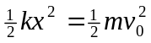, and solving for the spring constant,
